Creating Microservices for account and loan:
In D drive , I have created a folder named “123456” inside it I have created “microservices” folder, inside it I have created two projects(folder) named “Account” and “Loan”.

AccountController.java
package com.cognizant.account;

import org.springframework.web.bind.annotation.*;

@RestController
public class AccountController {

@GetMapping("/accounts/{number}")
public Account getAccount(@PathVariable String number) {
return new Account(number, "savings", 234343);
}
}

Account.java (Model class)
package com.cognizant.account;

public class Account {
private String number;
private String type;
private double balance;

public Account(String number, String type, double balance) {
this.number = number;
this.type = type;
this.balance = balance;
}

// Getters and Setters
public String getNumber() { return number; }
public void setNumber(String number) { this.number = number; }

public String getType() { return type; }
public void setType(String type) { this.type = type; }

public double getBalance() { return balance; }
public void setBalance(double balance) { this.balance = balance; }
}

OUTPUT:
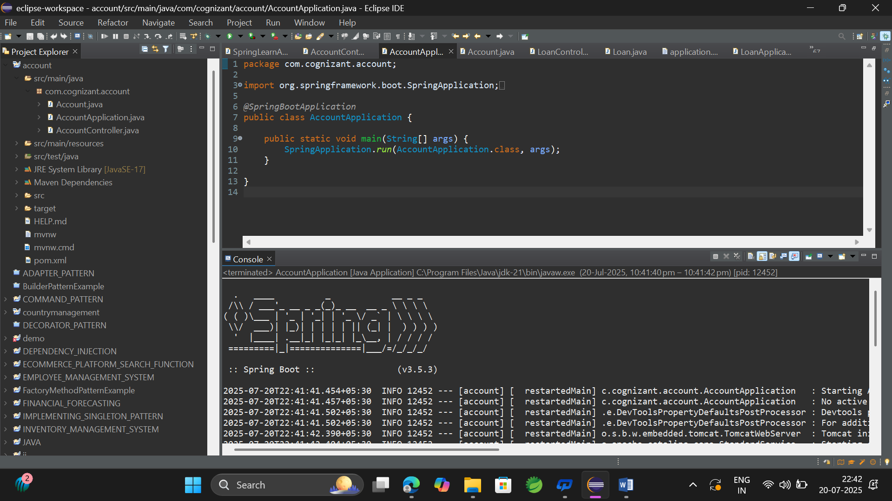

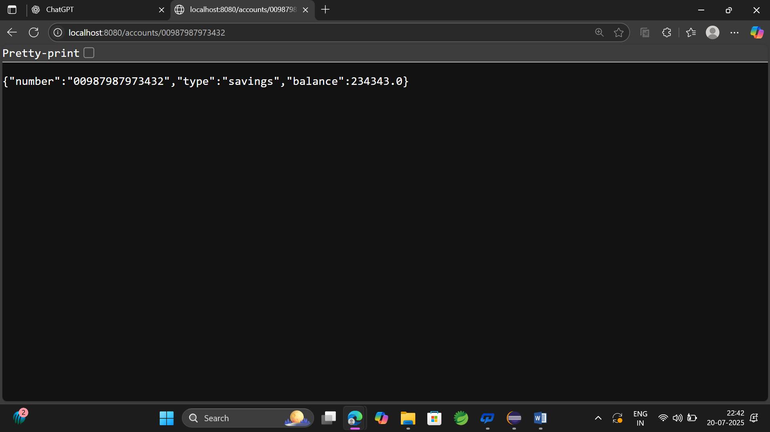

LoanController.java
package com.cognizant.loan;

import org.springframework.web.bind.annotation.*;

@RestController
public class LoanController {

@GetMapping("/loans/{number}")
public Loan getLoan(@PathVariable String number) {
return new Loan(number, "car", 400000, 3258, 18);
}
}

Loan.java(Model class)
package com.cognizant.loan;

public class Loan {
private String number;
private String type;
private double loan;
private double emi;
private int tenure;

public Loan(String number, String type, double loan, double emi, int tenure) {
this.number = number;
this.type = type;
this.loan = loan;
this.emi = emi;
this.tenure = tenure;
}

// Getters and Setters
public String getNumber() { return number; }
public void setNumber(String number) { this.number = number; }

public String getType() { return type; }
public void setType(String type) { this.type = type; }

public double getLoan() { return loan; }
public void setLoan(double loan) { this.loan = loan; }

public double getEmi() { return emi; }
public void setEmi(double emi) { this.emi = emi; }

public int getTenure() { return tenure; }
public void setTenure(int tenure) { this.tenure = tenure; }
}

OUTPUT:
